TW // Sexual Content, Parasocial behavior

At the time I’m writing this, the full details have not been released yet. I don’t know everything. I’ve spoken to some victims and members of the mod team and I understand the gist of what’s going to be released, but in terms of the exact information, I have no idea.

This Google Document is meant to relay all of my own personal experiences with Shayy and one that I’ve decided to release on my own.

For the longest time, I wanted to say something. However, Shayy’s community is much bigger than mine, and their influence among the Undertale community made me too scared to release or say anything. I also didn’t know who to talk to about this because of how high Shayy’s reputation is. I felt that if I made any accusations or explanations, I would lose my job, and face an insane amount of backlash. Now that there have been more victims coming forward, I believe I feel far more secure in coming out about this.

While most people assume that the stuff we talked about were strictly business or content creation related, this is not the case. While we do talk about that stuff, Me and Shayy have had several explicit conversations. Including but not limited to flirting and sexual stuff. Before me and my gf started dating officially, Shayy was already flirting with them. This was mainly just the typical “Queer-coded” type of flirting where they would be like “oh you’re so cute”. I feel like in the Queer community, these kinds of compliments are very common, so it wasn’t really anything out of the ordinary. Unfortunately, as time had progressed on, Shayy got more and more sexual towards me and my gf, to the point where we couldn’t get any other conversation with them without it turning into something sexual. I want to explain all of this in full detail in this document.

This document will be separated into a bunch of different parts explaining all of my weird interactions with Shayy and how infuriating it was talking with them.

My dynamic with Shayy

My friendship dynamic with Shayy is that while we do talk about business, we often do “Queer-coded” kind of flirting. As in calling each other cute or pretty, headpats, y’know the typical “uwu” kind of talking with each other.

I think this kind of flirting is frequently represented in LGBTQ+ communities. Spoken from a trans girl who often interacts with other trans people. And while the flirting started off fine and typical and very rare, Shayy would eventually take it way too far and would also make it so the flirting was very consistent.

I changed my server icon to a new one (we do frequent art contests there) and Shayy DM’s me, talking about… the boobs in the icon.
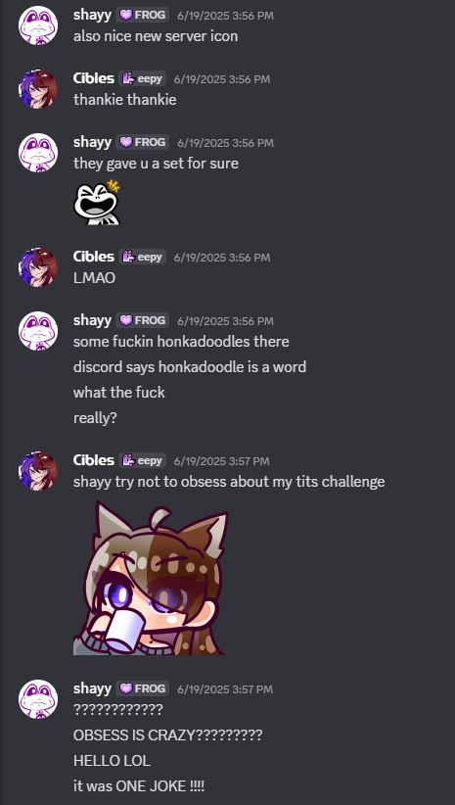
“It was one joke” they say, but this wouldn’t be the first time Shayy had been interested in my tits. In 2023, they said that my model had “gigantic boobs”.
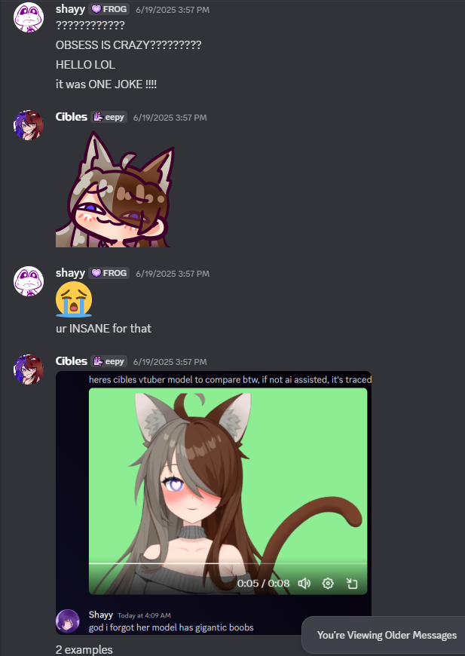
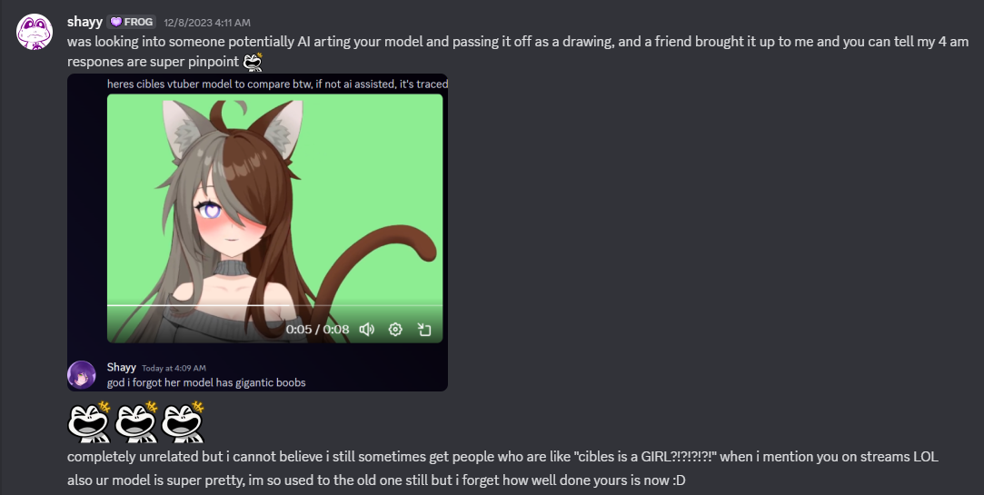
Screenshot from messages in 2023

When we had conversations around my boobs and sex, that’s genuinely the only times where I felt like I was having an actual conversation with them.

Y’know what our conversations looked like without sexual stuff involved? Here’s some examples.
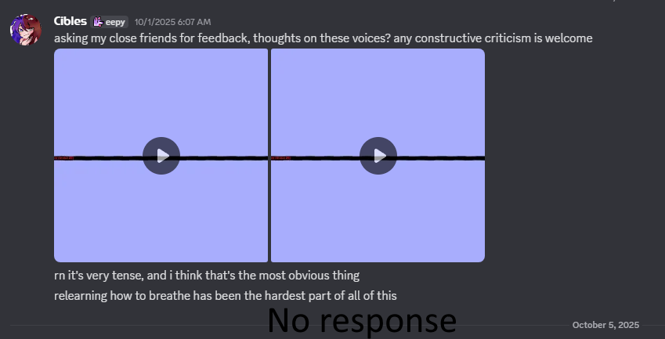
I was asking for feedback on my voice when I was in voice training lessons. No response.
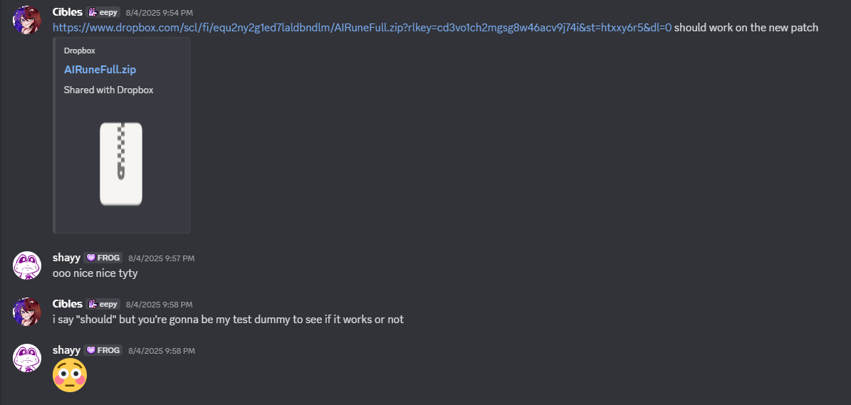
Side note: why the flushed emote here???

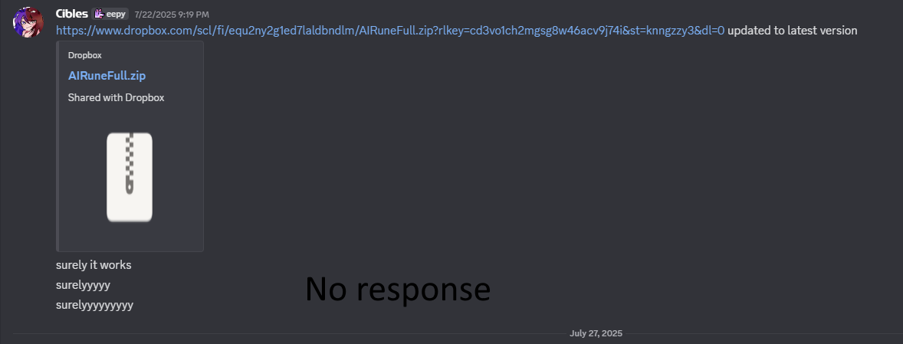

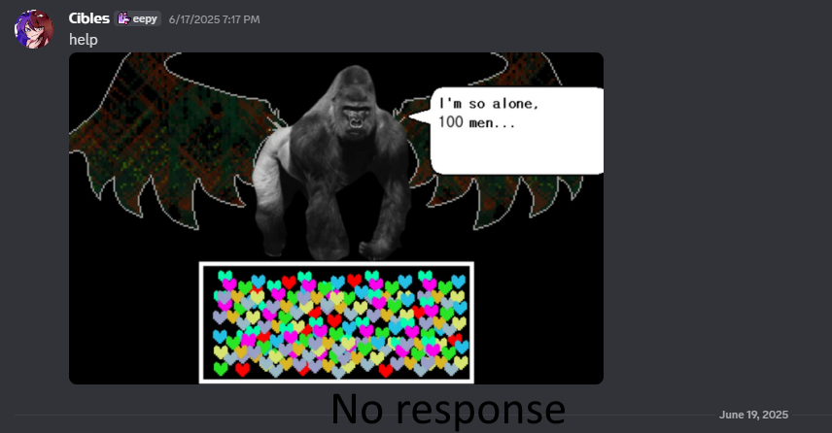
Anytime I tried having any sort of normal conversation with them, anytime I wanted to get to know them better, or talk about ANYTHING, they wouldn’t respond or give me barely anything to converse about. It got to a point where the only times where we actually TALKED was during sexual interactions.

Shorts Situation

My YouTube Shorts editor and girlfriend, Zaywire (referred to as Ava), had been looking for work outside of me for a bit now. She had been already friends with Shayy, which had led her to believe that Shayy would be a good option to pick up more work. Her and I have been trying to get a house together for a while, which is why we’ve been working so hard to get as much work as possible.

After contacting Shayy about making YouTube Shorts, they said yes. Everything was looking good and the YouTube Shorts were discussed to start uploading on July 1st this year. In order to create YouTube Shorts however, Ava needed a bunch of stuff from Shayy. She needed the raw scripts, the audio recordings, and any and all information about how they wanted the Shorts to look like. She needed complete and active communication with them. Leading up to the date of July 1st, despite her needing this stuff, Shayy wouldn’t give her any of the material that she needed to start working. Which caused massive amounts of anxiety between both me and Ava of meeting the upload start date of July 1st. Ava begged Shayy FOR WEEKS to get the material she needed from them. She would sometimes get no response or very vague ones. Which led me to have an idea.

I often noticed that Shayy often responds very frequently to sexual related messages. Just based on stuff I’ve heard from Ava and my own experiences. Neither of us knew how long it would take for Shayy to finally get the shit Ava needed, and there was barely any communication between them and her. So I had the idea of offering a picture of my boobs to them. My thought process was, “okay they’re really active and actually talk to me when sexual activity between us is present. If I offer a picture of my boobs to them, I wonder if they’ll actually give Ava what she needs to make her Shorts”. Honestly I didn’t expect them to take this offer seriously.
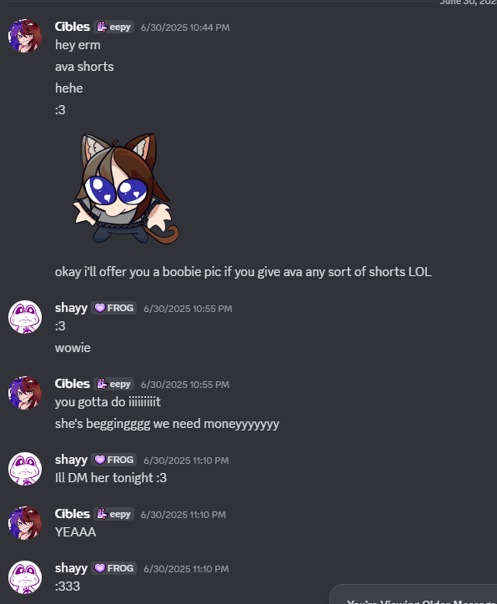
When I sent this message to them, I believed that they would take it as a joke…. They didn’t. Sending a picture of my boobs to Shayy, caused them to FINALLY get the material that Ava needed to start working on Shorts.
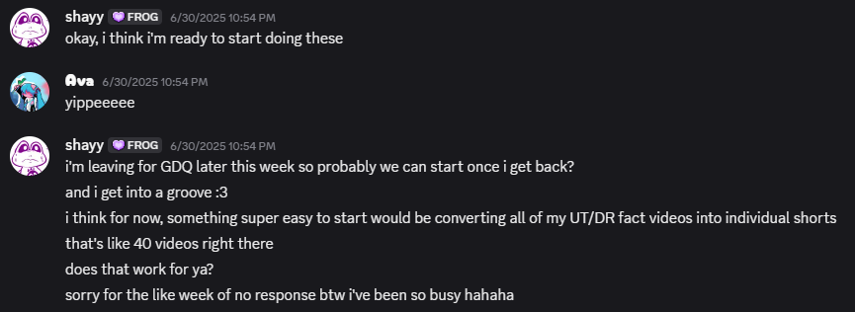
(Screenshot which would be 3 hours after the offer because of timezones) -Ava
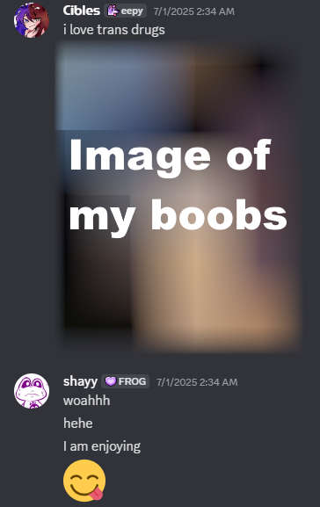
Unfortunately, the start date for Shorts on July 1st was completely missed and the schedule was completely thrown out of whack. It took until THE LAST DAY IN JULY to finally get the stuff Ava needed.
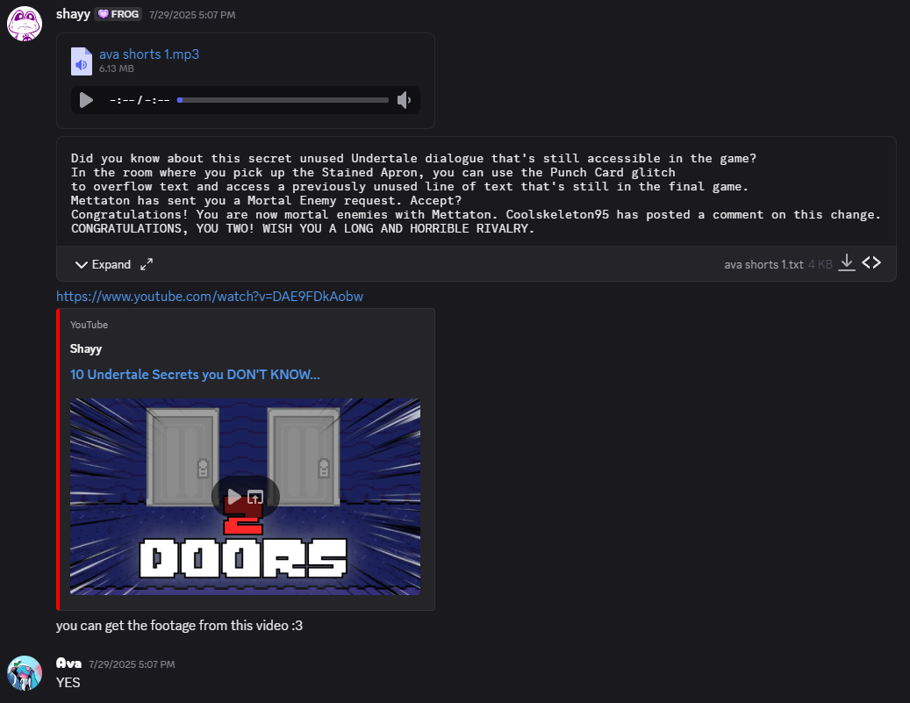
Why did I offer a picture of my boobs? Because we tried everything. And it was absolutely clear based on their past interactions with Ava and me, that when presented with sexual content, we can actually have a CONVERSATION. (Note: it was requested by Ava to not provide screenshots as to what her past flirting interactions were with them)

Even after I offered the picture of my boobs and Shayy got the materials for Ava, there was still content and questions that she needed in order to continue creating Shorts for them. This was meant to be a long term thing and we needed complete and active communication between us, but Shayy just was NOT giving it to us. The information that she needed still took forever to get to her and anytime that she wanted to discuss work related stuff, Shayy would often turn it sexual instead.
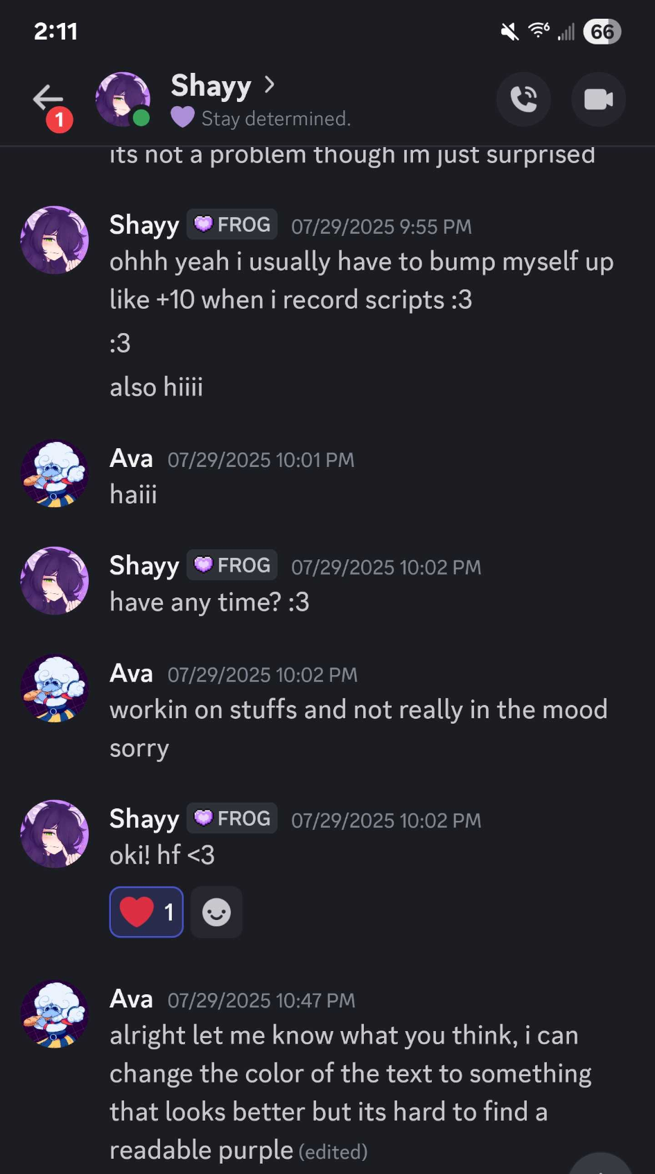
“Have any time?” being the sexual flirting
In this screenshot, you’ll notice that this is only a couple hours after the work related stuff she needed was given to her. Immediately after, they were requesting sexual stuff from her. WHILE THEY WERE TALKING ABOUT THINGS WORK RELATED.

Ava started venting to me about everything that was going on and so I decided to take this directly to Shayy themselves about what Ava told me
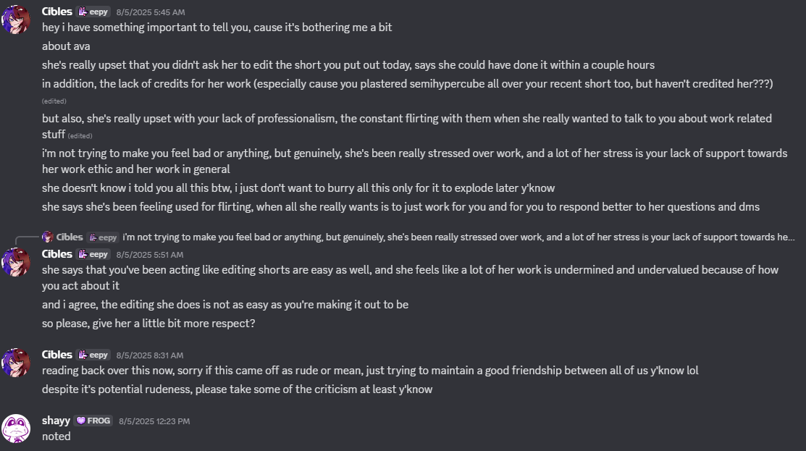
Shayy’s response to what I said? They called me rude.
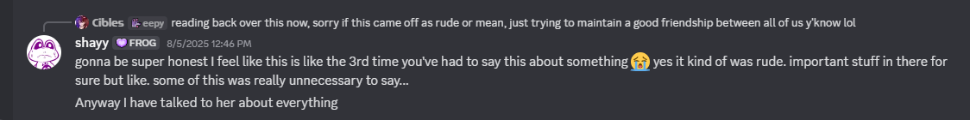
Not only did this reinforce my feeling of being scared to come out about all of this, but it made me super scared to say “no’ to absolutely any time they would flirt with me. I was scared of a response like this, all the time.

Shayy cannot take criticism.

Shayy has a really hard time accepting criticism or being accused of anything. I could never say no to them because they would get upset and I was so scared of losing everything. They have such a hard time with impulse reactions. Their behavior was so incredibly unpredictable. I felt like I couldn’t go to them about anything that would relate to criticism.

I made a tweet a bit ago, talking about the “I can’t read I’m an Undertale fan” meme and how overly annoying it was getting. I have dyslexia, and it was being used against me constantly in the comments. I also noticed people across the Undertale fandom being upset about the meme too.

Shayy DM’s me after I made this tweet, explaining that they’re tired of it too.
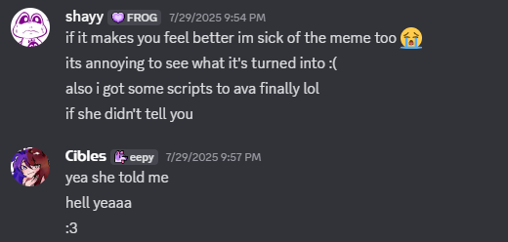
However, after telling me this, THEY TOLD ME TO DELETE MY TWEET
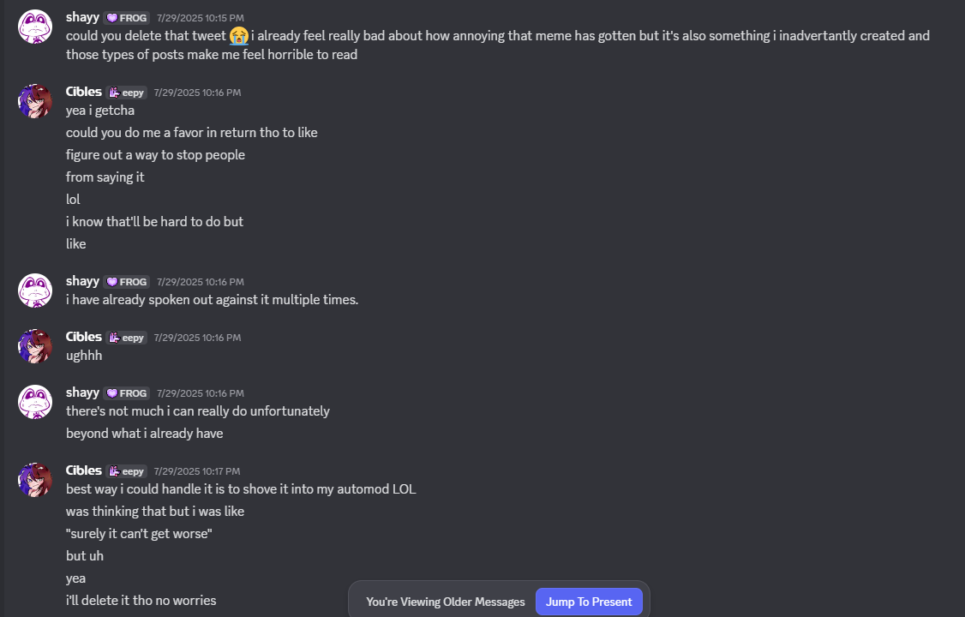
What a terrible thing to say. Especially after me and so many others are getting harassed over this meme. I was trying to speak out about it, to get people to stop, but of course, Shayy can’t handle getting their feelings hurt.

Can you blame me for not fighting back here and giving in? If I didn’t delete the tweet, they would just double down, get more upset, sad, emotional, whatever. And if they react badly enough, they could easily have a reaction that could cause their fandom to harass me. They’re scary. Especially when emotional.

Their lewd account

After sending the picture of my boobs, I got invited to their lewd account on Twitter. This was on my request because I wanted to see what they were saying to my girlfriend. When I got invited, I went through their follower list, and I saw so many of my fans from my own community following it. This lewd account had uncensored pictures of their penis, ass, among other things. I felt so incredibly creeped out because the people following it were members from our communities that would frequent mine and their chat. Especially because I’ve tried my absolute hardest to make sure that my community does not know about my personal life. It screamed parasocial to me. They were inviting people from THEIR FANBASE to their personal lewd account that contained a massive amount of explicit pictures of themselves. Their lewd account has since been deactivated.

Us Flirting

Once I sent the picture of my boobs to them, Shayy also got more and more open with flirting with me. I expressed that I was comfortable with it, because I was scared of their reaction if I said no. So it kept continuing. Most of my time flirting with them, it would just be me barking with Shayy trying to fluster me. I chose barking instead of giving any proper response because I didn’t want to flirt in the first place, but I was so incredibly scared of just saying no. So I wanted to strike a middle ground. Just enough to not hurt their feelings.

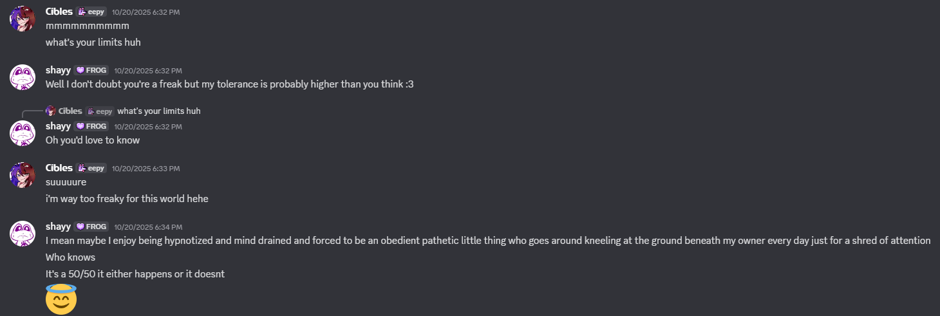
You can see the intimidation in my messaging here. I just kept saying that “I’m far more freakier than you” because I didn’t want to reveal much to them. It was during this sequence of messaging, that they revealed that they are into hypnotism.

Shayy tried switching it around, so that I would go along with their fetish instead of them just flirting with me. Basically wanting to make our flirting more than just me barking at anything they would give me.

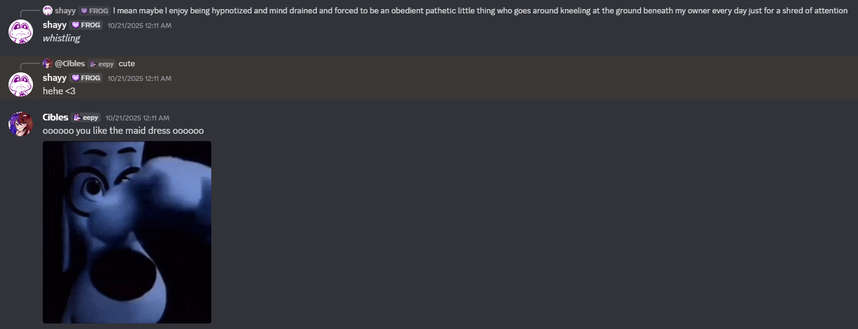
So when Shayy told me this was their fetish, and wanted me to take action on it, I tried my absolute hardest to put them off without directly saying no. You can tell from this screenshot how not into this I was, but Shayy kept doubling down.

Eventually they asked if I was “having fun” during the flirting. This is a perfectly okay thing to do normally, but the problem is HOW they asked this.
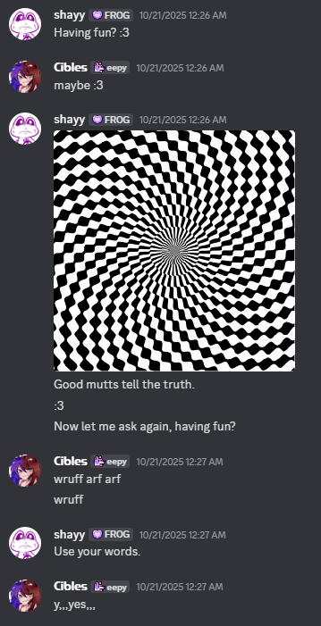
I was so uncomfortable with what was happening at this point. I didn’t say yes initially, and I was scared to say “no” so I said “maybe”. Shayy then sent a hypnotism GIF. I then felt forced to say yes.

This is not how you ask for consent and it only made me more intimidated to say no.
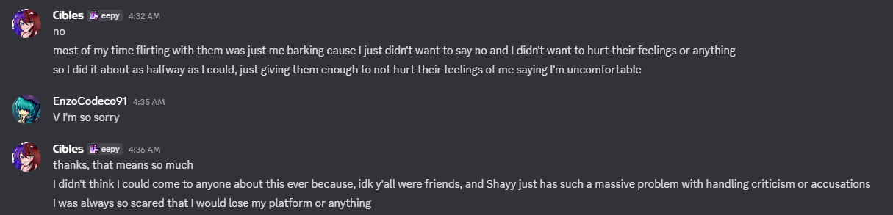
Me talking about it to Enzo (Shayy’s mod)

Why the mod team released their initial response (The WillyJ post)

I have no idea if this is going to be covered in the information that will be released to the public. So I’m going to write about it here so that people know why that initial WillyJ post was made, just in case it’s not covered.

When the accusations were first relayed to Shayy, Shayy had an absolute terrible reaction to everything. They deleted the Owner role from their own server and went dark (black profile picture, that sorta thing) and left from the speedrunning community. This naturally raised a lot of questions because of the shit reaction from Shayy.

WillyJ’s post was an attempt at damage control from Shayy’s reaction. However, they needed more time to release the information to the public. Especially because more and more details were still being released at the time of Shayy’s reaction. The team needed more time to release the info, but they also needed to get ahead of Shayy and make sure that Shayy wouldn’t try to make themselves seem like the victim in the situation. The mod team had good intentions, and it was never meant to be seen as purposeful drama. It was simply them just trying to do as much damage control as possible without jeopardizing the victims. They wouldn’t have had to make the post to begin with if Shayy didn’t have the reaction that they did. Yet another piece of proof that Shayy cannot take criticism.

Conclusion

I think a lot of people had it worse than me at the end of the day. Just judging based off of everything. I’m so incredibly sorry to anyone that has been affected by this, and once this information is finally released, I’d imagine that more victims are going to come forward. This was a massive situation. Shayy had DM’s open, and anyone that joined Frog Family (their Discord) were subject to Shayy’s sexual actions. So I would not be surprised if there are plenty more victims that we simply don’t know about yet. All collaborations I did with Shayy are going to be set as “Unlisted”. I never want to associate with them again.

If you have had any experiences like this with Shayy, there are a mountain of people that are willing to support you. You are not alone.

